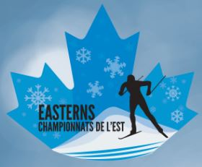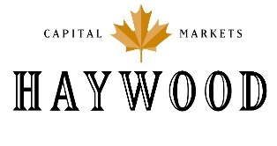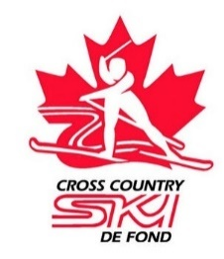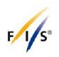

Media Release:
Largest Canadian,” Olympic style” X-C Ski Race returns to Ottawa-Gatineau: UPDATED
The Haywood NorAm, Eastern Canadian Championships, will be held from Feb. 2-4 at the Nakkertok Nordic Centre, 900 Ave Gatineau, Gatineau Quebec. Fri. 9:00-3:30; Sat. 9:00-1:30; Sun. 9:00-12:00.
The race will attract over 800 competitors from across N. America, Alaska to Newfoundland. It is also part of the FIS Continental Cup’s: Canadian Haywood NorAm National race series, and a stop on the USA Super Tour series. Over 80 clubs from across Canada will be participating from 10 provinces/territories, along with 10 clubs from across the U.S.
Athletes entered will include:
- Rossland B.C.’s Julien Locke, 15th in the World at the January, Dresden World Cup.
- Gatineau’s Dominique Moncion-Groulx, Canadian January World Cup Team.
- US Olympians: Rosie Frankowski, Anchorage, Alaska; Kaitlynn Miller, Craftsbury, Vermont.
- 4X US Olympic Team Member, Kris Freeman, Concord, New Hampshire.
- Canadian Para-Nordic, World Cup athletes: Ethan Hess, Vancouver; Sebastien Fortier, Quebec City, Derek Zaplotinsky, Edmonton.
- A group of over 25 young athletes on an exchange from Foothills Nordic Club, Calgary, Alberta.
- 15 of Canada’s future Olympians from the Canmore, Thunder Bay and Quebec Training Centres.
The Haywood Eastern Canadian Championships is being hosted in the region for the 14th year, and is jointly organized by 3 local clubs, Chelsea Nordiq, Club Skinouk and Nakkertok Nordic that will provide over 550 volunteers for the event.
For more information, interview arrangements etc., please contact:
Anton Scheier: 613-601-8257 or Marie-Pier Pelletier-Millette: 819-593-1159
cecski.communications@gmail.com
http://cecski.ca
